JoSVAS 2026 September Vol. 8 Issue 3: 254-259
©2026 College of Veterinary Medicine, Original Research Article
Michael Okpara University of Agriculture, Umudike, Nigeria

PREVALENCE OF AFRICAN SWINE FEVER IN PIGS MANAGED UNDER VARIOUS PRODUCTION SYSTEM IN KADUNA STATE, NIGERIA

^{*1}ADENAIKE, E.A., ¹OGBONNA, I.J., ¹AKPAN, C.A.N., ¹TCHOKOTE, Y.E. & ²OLAOGUNS, C.

¹Department of Veterinary Medicine, Michael Okpara University of Agriculture, Umudike, Abia State, Nigeria; ²Department of Veterinary Medicine, University of Ibadan, Ibadan, Nigeria
*Correspondence: adenaikelara@yahoo.com; +2348026580689
ABSTRACT
African Swine Fever (ASF) is a notifiable, highly contagious, lethal haemorrhagic and devastating viral disease currently threatening the pig industry worldwide. Its status in Kaduna state with respect to the various pig farm management systems are not fully known. Pigs on extensive and semi intensive systems are easily infected with ASF virus due to contact with other pigs from various sources and their scavenging habits, such as feeding on what has been contaminated by infected pigs or pigs that died of the disease, and on garbage contaminated by remains of infected pigs. This study was designed to sero-monitor the prevalence of ASFV by determining the presence or absence of antibodies to ASFV under various production systems. Out of a total of 299 blood samples collected from pigs of various ages and clinical status, 10 (3.34%) were positive to ASF by indirect ELISA. Two out of the three senatorial districts, showed pigs that were sero-positive in extensive or semi intensive system of production managements system. The mean antibodies titre to ASFV in the three senatorial districts was highest in pigs in Kaduna South with 21.27%, followed by the pigs in Kaduna North with 17.52% and lowest in pigs in Kaduna Central with 12.02%. The mean antibodies titre to ASFV of pigs under extensive or semi intensive system of production managements was 23.71% while the mean antibodies titre of pigs under the intensive system was 13.25% in Kaduna State.
Keywords: African swine fever, antibodies titre, Kaduna state

INTRODUCTION
African swine fever (ASF) is a notifiable, highly contagious, lethal haemorrhagic disease in domestic pigs (Rahimi et al., 2010). The African swine fever virus (ASFV) is an enveloped double stranded DNA virus. Maintenance and transmission of ASFV involve cycling of the virus between soft ticks of the genus Ornithodoros spp. and wild pigs and can also be acquired through ingestion of contaminated feed (Rahimi et al., 2010).
The mortality recorded was 125,000 in 9 States of the Federal Republic of Nigeria namely Lagos, Ogun, Kaduna, Benue, Enugu, Akwa Ibom, Rivers, Plateau and Delta States (El-Hicheri, 1998). Most of the affected herds were owned by small-holders of between 1 to 50 pigs per farm (El-Hicheri, 1998). The virus is transmitted directly during contact between infected and susceptible pigs, by consumption of the meat scrap from infected pigs, by the bites of infected ticks (Ornithodoros spp.) and by contact with objects contaminated by virus-containing matter. Hence, pigs on free-range are easily infected with ASFV due to contact with other pigs from various sources and their scavenging habits (Penrith & Wilna, 2009).
People moving pigs and their products, over long distances also act as transmitters of the virus from contaminated to uncontaminated premises without any hygienic precautions (Penrith & Wilna, 2009). Pigs that recover may shed virus for up to a month after the disappearance of clinical signs and since it is quite resistant to high temperatures, requiring exposure to a temperature of 60°C for at least 20 minutes for inactivation (Penrith & Wilna, 2009). To ascertain the presence or absence of the disease, at the present stage, the only way out is to conduct an epidemiological investigation throughout the country (El-Hicheri, 1998).
Protein consumption is important for the physical, mental and physiological development of man and proteins from animal sources are superior to those from plants (Ekue & Wilkinson, 2000). The pig population contributes highly to the food security of the low income rural and peri-urban population in some parts of Nigeria. Pork remains the cheapest source of meat in Nigeria (El-Hicheri, 1998).
African swine fever is characterized by an acute generalized infection with incubation period of 3 to 4 days, accompanied by high temperature, dullness, loss of appetite, cyanosis and incoordination of the hind legs. The mortality rate is usually 100% with only an occasional animal survivors (Merchant & Parker, 2005).
The first outbreak in Nigeria, which occurred in September, 1997, was associated with a spread of the epizootic from Benin Republic and most of the declared uninfected States were basing their declaration of ASF-free status only on the absence of ASF reporting which is not satisfactory (Otisville et, al., 2005).The usual route of an ASFV infection in pig is via the oral route or the upper respiratory system from droplets inhaled. The ASF virus provokes proliferation of lymphocytes and reticular cells. After four days, degeneration becomes more prominent than proliferation (Ayoade & Adeyemi, 2003).
Swine that survive the infection may appear healthy or chronically diseased, but may remain persistently infected without showing clinical signs (Murphy et al., 1999).
Enzyme-linked immunosorbent assays (ELISA) test has been developed for long time for a variety of antibodies against the highly antigenic ASF viral proteins p30, p54, and p72. More than 90% of infected pigs can be detected by this method. The test is highly specific and sensitive and is used as a screening test on a large scale. (Radostits et al., 2007). There is no treatment for ASF other than supportive care (Murphy et al., 1999, Radostits et al., 2007). Slaughter of affected pigs is recommended especially in non- endemic area (Radostits et al., 2007).
Extensive system is small-scale where pigs scavenge in the street, garbage dumps, neighbouring land, river banks and/or forests around villages. This system has been documented to result in risk of exposure of pigs to diseases including ASF (Eusabio, 1980; FAO, 2017). Semi-intensive system is also small- scale confined pig production system which involves keeping pigs in shelters with various degrees of sophistication that include simple pens made with local materials to more modern housing and provision of feed. The producers in this system raise pigs for both subsistence and commercial reasons. Pigs are also occasionally allowed to scavenge around (Eusabio, 1980; FAO, 2017). Intensive system is a large-scale commercial pig producing enterprises. Movement of pigs are restricted because adequate housing is provided through the year. (FAO, 2017).
The aim of the present survey was to sero-monitor the prevalence of ASFV in Kaduna state, Nigeria, by determining the presence or absence of antibodies to ASFV under various production systems in the state.

MATERIALS AND METHODS
STUDY AREA
The study area involved all the local government areas (LGAs) in Kaduna State. The state is geographically located in Northern Nigeria shown in Figure I (Dada et al., 2010). The global location of the State is between Longitude 06o and 11o 3’ North of the Equator. The State occupies an area of approximately 48,732.2 square kilometres (Jallo, 2000). Kaduna State has 23 Local governments Areas (Jallo, 2000). The 23 LGAs are grouped into Kaduna North, Kaduna Central and Kaduna South Senatorial Zones. The State capital is Kaduna. The Study area in Kaduna State is shown in Figure II.
Pigs from 15 LGAs were sampled out of the total number of 23 LGAs, in Kaduna state. More samples were collected from the LGAs with the highest pig population and from both commercially managed and traditionally managed pigs from all systems of management. There was questioning to farmers about the source of the animals and various production management systems the pigs were managed before the blood samples were collected.

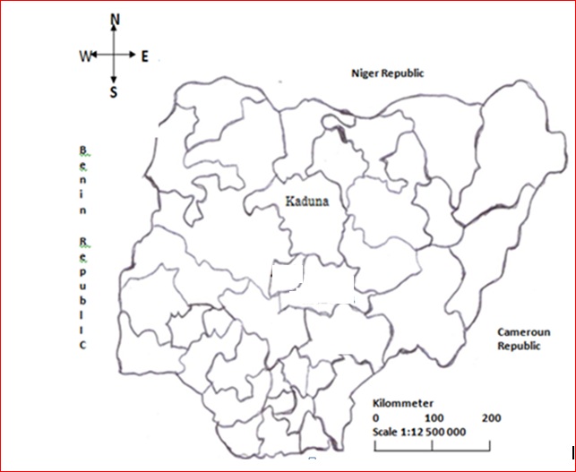

Figure I: Map of Nigeria showing Kaduna State that was under study (Dada et al., 2010)

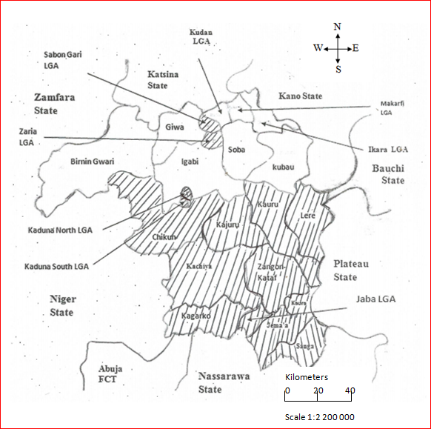
Figure II: Map of Kaduna State and its Local Government Areas showing sampled areas (Shaded)

STUDY MATERIALS
Consumable materials that were used for the study included serum sample collection bottles, vacuotaner tubes, heparinised tubes, methylated spirit, viral transport medium, needles and syringes (2 ml and 5 ml), methanol (99%), glycerol, cotton gauze, disinfectant, detergent, microhaematocrit capillary tubes (plain), Natt-Herrick` diluents, vials, ELISA kits and result sheets. The Vet. Innovative Diagnostics kit component for detection of ASFV antibody include Microplates coated with p32, p62, p72 ASFV recumbent proteins (biwelformal), concentrated conjugate (10X), positive control, negative control, dilution buffer 14, dilution buffer 3, wash concentrate (20X), stop solution (H2SO4, 0.5m). Others include adsorbent paper, glass or plastic pipettes for volume of 1-10 ml, power supply, and single channel pipette 1. The non-consumable materials used for the study were thermometer, weighing ban, cooler (for transporting samples), 96-well microplate reader, manual or automatic wash system, and camera, others were freezer, ELISA recorder and computer, photograph, equipment and printer. Freezer <-10OC, freezer ≤-70 C, Fridge 4±3O C, tray for horizontal agarose gels, tank, combs, UV transiluminator and vortex.

SAMPLE SIZE DETERMINATION
The sample size was calculated as described by Awa et al. (2009) on the prevalence rate in Northern Cameroon of 2% positive for 150 samples. Sample size was determined using the formula;
n = Z2PQ
L2

When n = Sample size
Z = standard normal at 95% Confidence interval (1.96)
P = known prevalence rate of the infection (2%) (Awa et al., 2009)
L = allowable error taken as 0.02
Q = 1-P
N = (1.96)2 x .02 x 0.98
0.022
= 188.2384.Not less than 200 were collected from the Kaduna State

BLOOD SAMPLES COLLECTION
Ethical approval was sought and granted by the ethical committee for experimental purpose of College of Veterinary Medicine, Michael Okpara University of Agriculture, Umudike, Nigeria (MOUAU/CVM/REC/202217). The samples collected were blood from live pigs from various farms and slaughter houses. Ten millilitres of blood were collected from the jugular vein of pigs following restraint by an assistant. Five millitres of the blood were put in an EDTA bottle and processed for haemogram in the laboratory. The remaining 5ml of the blood were put in a non-EDTA bottle for serum preparation. The blood containing anticoagulant was used for heamatology while those for sera was allowed to clot and then centrifuged and stored at -20OC until examined. Both samples were kept in a cooler for transportation to the laboratory for investigation and analysis.
SERUM PREPARATION
In the laboratory, the blood for serum was centrifuged at 1500 g for 10-15 minutes for the purpose of separation of the serum. The serum samples were then decanted in serum tubes and the corresponding numbers of the tubes written on the serum tubes. The serum samples were then kept at -200C till used for serology.
Indirect Enzyme Linked Immunosorbent Assay (i-ELISA) was used for the conduction of the serology. Thei-ELISA kits were sourced from ID Vet Innovative Diagnostics (ID vet, 310, Rue Louis Pasteur-Gravel-France). The procedure as described by the manufacturers was followed strictly. Briefly, the wash concentrate (20X) was brought to room temperature and then mixed thoroughly to ensure that it was completely solubilised. The solution 1X was prepared by diluting the wash concentrate (20X) to 1/20 in distilled/deiodised water. All reagents were allowed to come to room temperature (16 - 26o Co C) before use and reagents were homogenized by inversion or vortex. Each sample was deposited twice (adjacently in even and odd-numbered wells) Serum samples. The ELISA plate (Figure III) had even-numbered micro wells that were coated with p32, p62 and p72 ASFV recombinant proteins, while odd-numbered wells were uncoated. Samples to be tested and controls were added to even and odd- numbered wells with anti-ASFV antibodies with the aid of micropipette, and formed an antigen-antibody complex where antibody was present. After washing, an anti-multi- species horse radish peroxidase (HRP) conjugate was added to the wells. It fixed to the antibodies, forming an antigen-antibody-conjugate-HRP in the presence of antibodies, into blue solutions which became yellow after addition of the stop solution. In the absence of antibodies, no coloration appeared. The microplates were read at 450nm. ELISA recorder and computer were used to record and result shown by ELISA recorder and computer were printed out. This was followed by the addition of 100 ul of the dilution buffer 14 to each well and tenmicrolitre of the negative control to wells A1, B1 and A2, and B2 while 10 ul of the positive control were added to wells C1, D1 and C2, D2 and 10ul of each sample to be tested to the remaining wells. Each sample was deposited twice (adjacently in even and odd-numbered wells). It was later incubated for 45 min at 21o C (+ 5oC). The wells were emptied and washed 3 times with approximately 300 ul of washed solution. Drying of the wells was avoided during washing. Conjugate 1X was prepared by diluting the concentrated conjugate 10X to 1/10 in Dilution Buffer 100 ul of the conjugate 1X was added to each well It was incubated for 3 min at 21o C ( + 5oC). The wells were emptied and washed 3 times with approximately 300 ul of wash solution. Drying of the wells was avoided during washing. 100 ul of the Substrate Solution was added to each well. It was incubated for 15 min at 21o C (+ 5oC) in the dark.100 ul of the Stop Solution was added to each well in order to stop the reaction. The micro plates O.D was red and recorded at 450nm. Result sheets were used in recording the result shown by the ELISA recorder and computer. The results were read as X 100
Well-O.D result was calculated as follows
O.D net = O. Deven - O.D odd well
S/P percentage (S/p %) was calculated
(S/p %) = Net OD sampleX 100
net OD PC

S/P percentage (S/p %) was calculated. Samples with an S/p%: Less than or equal to 60% were considered negative; greater than or equal to 60% were considered positive.

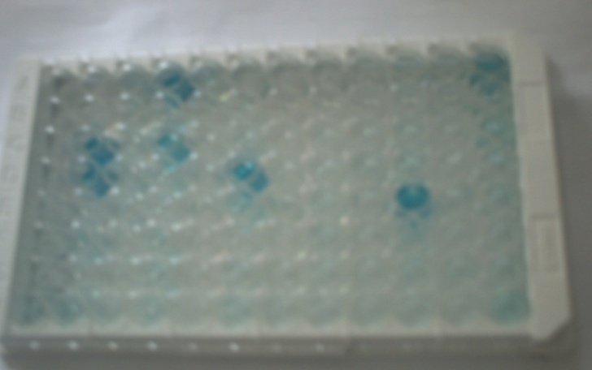

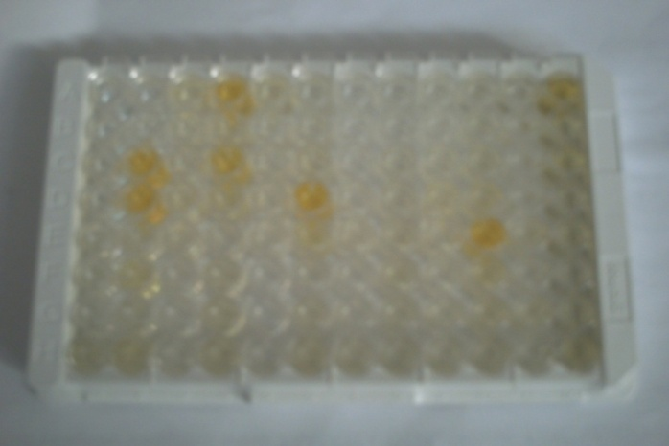
Figure III: ELISA Plate showing presence of African Swine Fever Antigen-Antibody Complex with blue coloration indicating positive (above) which turned yellow after addition of the Stop Solution (below)

RESULTS
Out of 299 pigs sampled in the study, 10 (3.34%) were positive for ASFV antibodies using the ELISA method. The sero prevalence (S/p) rates by senatorial districts and LGAs in Kaduna State were shown in tables I to XIV. The parameters about the S/p % of the serum samples of the pigs in various local government areas Kaduna States are as follows:

THE MEAN TITRE LEVEL OF ANTIBODIES AND SEROPREVALENCE AGAINST AFRICAN SWINE FEVER VIRUS AND THE VIRAL ANTIGEN IN KADUNA STATE IN VARIED MANAGEMENT SYSTEMS

The mean S/p% titre level and percentage seropositive samples in the various management systems in the three senatorial districts in Kaduna state were represented in the table below.
Out of the 20 pigs sampled in Sabon Gari LGA, 2 (10%) were seropositive, while 2 (16.7%) out of 18 pigs in Saminaka LGA of Kaduna North senatorial district were sero-positive. No pig was sero-positive in Kaduna Central district. In Kaduna South senatorial district of the State, seropositivity was recorded in Kachia {2 (8.0%) 25}, Jaba {1(5.6%) 18}, Jama’a {1(5.3%) 19}, Kaura {1(6.7%) 15} and Sanga {1(5.6%) 18} respectively.
The result of the survey, as presented in the table below showed that pigs managed under extensive and semi intensive system (that allow animal movement) have higher mean titre (23.71%) than those managed under intensive system or animals in confinement (13.25%). Samples of pigs from Saminaka and Sabon Gari LGAs were from those pigs managed under extensive and semi intensive system. The samples from Zaria LGA were from pigs managed under intensive system or in confinement. Sabon Gari LGA have the hghiest titre level (25.45%) followed by Saminaka LGA (22.04%) and the least was in Zaria LGA (13.16%) The mean titre level of antibodies against African swine fever virus and viral antigen in the serum samples of pigs in various Local Government areas in Kaduna Central senatorial district are as shown in the table below. All the samples from Kaduna North, Kaduna South, Chiukun and Kajuru LGAs were from those pigs managed under intensive system or in confinement. No sample was collected from pigs managed under extensive and semi intensive system in Kaduna Central senatorial district. The mean titre was very low in the serum samples of pigs from all the LGAs Kaduna North, Kaduna South, Chiukun and Kajuru LGAs had 15.77%, 9.90 %, 12.48 %, and 11.16% titre respectively.
The mean titre level of antibodies against African swine fever virus and viral antigen in the serum samples of pigs in various Local Government areas in Kaduna South senatorial district are as shown in the table below. Samples of pigs from Kachiya, Jaba, Jama’a, Kaura, Kauru and Sanga LGAs were from those pigs managed under extensive and semi intensive system, had the highest 28.16%, 25.78%, 19.57%, 22.07%, 24.26%and 20.59% respectively. The samples from Zangon Kataf and Kagarko LGAs were from pigs managed under intensive system or in confinement had the lowest mean titre of 16.66% and 14.67% respectively.

DISCUSSION
Kaduna south Senatorial district had the highest mean S/P percentage titre level of 21.47% followed by Kaduna north Senatorial district with mean S/P percentage titre level of 20.2% while Kaduna central Senatorial district had the lowest mean S/P percentage titre level of 12.33%.
The result from Kaduna north Senatorial districts was observed in Sabon Gari, Saminaka and Zaria LGAs. The high ASFV antibody detection rate, S/P percentage titre level in Sabon Gari and Saminaka LGAs could be due to pig population, extensive or semi intensive system of production managements which allowed increased interactions between pigs, pig waste and, pig by-products in the environment from different sources, allowed pigs to come in contact with people and their materials especially in Sabon Gari LGA because of the proximity of the University with different people all over the country that could be mechanical carriers of the virus and the viral antigen particularly those from other pig producing areas from different part of the country that live around the campus area. In addition pig dealers also come from as far as Benue, south eastern and south states to buy pigs. The vehicle and other equipment used could also spread the virus and the viral antigen to the environment and when these pigs reared under extensive or semiintensive systems come in contact with the virus and viral antigen they will be challenged to produce antibodies and also aid in the transmission of the disease or become carriers. In Zaria LGA, zero prevalence rate and low titre level of antibodies against ASFV is likely to be because animals are kept in confinement to prevent them from been knocked down by vehicles on express busy roads and to prevent them from causing social problems with neighbours. Since they are kept in confinement they are likely not to come in contact with virus and viral antigen and hence less challenge on the animals to produce antibody against the disease. In addition the human population around Zaria LGA is not as high as in Sabon Gari LGA.
The second highest detection rate was Kaduna south senatorial district with detection rate was 4.1% of antibodies against ASFV in this study. This was observed in 6 LGAs out of 8 LGAs. This observed differences in Kachiya, Jaba, Jema’a, Kaura, Kaur and Sanga LGAs in Kaduna south Senatorial districts could be due to pig population (highest in the three senatorial districts), extensive or semiintensive system of production managements which increased interactions between pigs from different sources, with people and their wastes in the environment especially in Jema’ because of the proximity the College of Education Kafanchan with different people all over the country that could be mechanical carriers of the virus and the viral antigen particularly those from other pig producing areas from different part of the country that live around the campus area. In addition pig dealers also come from as far as Benue, south eastern and south southern states to by pigs. The vehicle used could also spread the virus and the viral antigen to the environment and when these pigs reared under extensive or semiintensive systems come in contact with the virus and viral antigen they will be challenged to produce antibodies and also aid in the transmission of the diseases or become carriers.
In Zangon Kataf and Kagarko LGAs, zero prevalence rate and low titre level (16.66% and 14.67% respectively) of antibodies against ASFV is likely to be because animals in Zangon Kataf LGA were kept in confinement to prevent social problems with neighbours. The animals from Kagarko LGA were kept under standard intensive system of pig management with biosecurity measures provided and the farm was located in a secluded area in which people could not get there except when permitted to do so. Since in both Zangon Kata and Kagarko LGAs cases the pig are kept in confinement they are likely not to come in contact with virus and viral antigen and hence less challenge on the animals to produce antibody against the disease.
The observed low prevalence rate in Kaduna central senatorial district could be related to the nearness of the most recent outbreak of ASF which occurred in 1998 in Sabon Tasha in Kaduna State (Otisville et al., 2005). With time the population of pigs affected in the outbreak would have been wiped out and new population of pigs could have emerged. There might have been also adequate biosecurity steps adapted by the farmers which might have contributed to the low prevalence reported in this study.
The prevalence in Jema’a LGA of Kaduna State. In this report (5.3%) was about the same (6%) reported by Luther (2001). According to Radostits et al. (2007), pigs with demonstrable antibodies should be considered as chronic or active carriers of the virus as it is doubtful that true recovery ever occurs after outbreaks. The pigs constantly or intermittently acquire the infection but do not show any clinical signs as far as they were not stressed thus the presence of antibodies to ASF may indicate the infection is maintained in the States in these pigs.

CONCLUSION
The study has demonstrated the presence of antibodies to African Swine Fever Virus (ASFV) in Kaduna State, Nigeria. The study has shown that 3.3%, pigs in Kaduna State were sero-positive for ASF. There are active carrier pigs of African Swine Fever Virus (ASFV) in pig populations in Kaduna State, Nigeria, although there may be no clinical signs were manifested in most of areas. The reasons for the spread of African Swine Fever Virus and or the viral antigen are present in Kaduna State environment especially Kaduna north and Kaduna south senatorial districts is mainly caused by the free movement of pigs which is due to the extensive and semi-intensive production system .
Further research work on the effect of spread of African swine fever in pigs when managed under various production system in Kaduna state and Nigeria as a whole. The eradication of African swine fever program in Kaduna State should start by controlling animal and human movements. There is need for awareness campaign to pig farmers to the implication of pigs moving freely in the community in the spread of ASFV infection. Only pigs reared under intensive system should be used as parent stock since they discovered to have lowest titre of ASFV antibodies.

CONFLICT OF INTEREST
Authors have no conflict of interest to declare.

REFERENCES
Awa, D.N., Njoya, A, Ngo Tama, A.C. & Ekue, F.N. (2009). Diseases in North Cameroon. The health status of pigs in North Cameroon Revue. Review of Veterinary Medicine in Tropical Countries, 52 (2), 93-98.
Ayoade, G.O. & Adeyemi, I.G. (2003), African swine fever: an overview Pig trop the information center about pig production and pork meat commodity chains in developing countries. Journal of Tropical Livestock Science, 56 (3-4), 129-134.
Brown, B. (1993). Hematology Principles and procedures 3rd Edition Massachusetts.
CFSPH (2015):.African Swine Fever, Centre for Food Security and Public Health cfsph@ astate.edu www.cfsph@iastate.eduand Institute for International.
Dada, F. O.A, Jibrin, G. M. & Ijeoma, A. (2010). Secondary school Atlas. Nigerian South West Geo-political Zonal /Region Published by Macmillan Nigeria Fourth Edition, pp. 10.
Ekwe, N. F. & Wilkinson, P.J. (2000). Pigtrop - the information center about pig production and pork meat commodity chains in developing countries. Comparison of genomes of African swine fever virus isolates from Cameroon, other African countries and Europe. Journal of Tropical Livestock Science, 53 (3), 229-236.
Ekwe, N. F. & Wilkinson, P. J. (2008). Comparison of genomes of African swine fever virus isolates from Cameroon, other African countries and Europe. IRAD Nkolbisson BP 2067 Yaounde, Cameroon. The Institute of Animal Health.
El-Hicheri, K. (1998). Emergency assistance on control and eradication of an outbreak of African swine fever in western Nigeria. Report of FAO consultancy mission to Nigeria. Food and Agricultural Organization of United Nations Rome.
Eusebio, J.A. (1980): Pig breeding (Tropical pig). Pig production in tropics. Longman; pp. 92.
Food Agricultural Organization (FAO) of the United Nations. (2017). Support to improved pig breeding system April.
Jallo, H. (2000). Vision and Actions for a Greater Kaduna state; the Makarfi Era.Vol.1: 5-8.
Luther, N. J. (2001), Serological investigation of slaughtered pigs for evidence of African swine fever virus antibodies in Plateau and Kaduna state. Veterinary Sciences, 3 (2), 44-46.
Madubuike, F. N. (2004): Arresting animal protein insufficiency in Nigeria: a multi-sectional approach. Journal of Agriculture and Food Science, 141.
Merchant, I. A. & Parcker, R. A. (2005). Veterinary Bacteriology and Virology Publishers and Distributors 4596/ I-A, 11 Daryaganji, New Delhi, = 110002 (India) Seventh Edition, pp. 703.
Murphy, F. A., Gibbs, E. P., Poul, J. H., Horzineck, M. C R. & Uddert, M. K. (1999). Veterinary Virology Third Edition San Diego London. Botson. New York Sydney. Tokyo Toronto, 293-298.
Otisville, E. B., Ajuwape, A. T. P., Odemuyiwa, S. O., Akpavie, S. O., Olaifa, A. K. & Odaibo, G. N. (2005). An outbreak of African swine fever in Nigeria. Journal of Tropical Livestock Science, 58 (1-2), 21-26.
Penrith, M. & Wilna, V. (2009). Public Medical Centre National Centre for Biotechnology Information U.S. National Library of Medicine8600. Rockville Pike, Bethesda MD, 20894USA.
Pirbright Laboratory, Pirbright, Surrey, GU24 ONF, UK .Journal of Tropical Livestock Science200053 (3): http://pigtrop.cirad.fr - Copyright CIRAD, pp. 229- 236.
Radostits, O. M, Gay, C. C, Hinchcliff, K. W. & Constable, P. D. (2007). Veterinary Medicine. A textbook of the diseases of cattle, horses, sheep, pigs and goats 10th Edition Saunders Ltd. ISBN: 978-0-7020-2777-2 Pp. 1167-1173.

