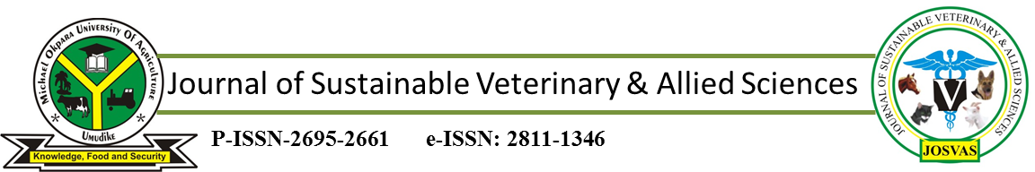JoSVAS 2026 September Vol. 8 Issue 3: 294-300
©2026 College of Veterinary Medicine, Original Research Article
Michael Okpara University of Agriculture, Umudike, Nigeria

THE LEVEL OF AWARENESS OF VETERINARY DIAGNOSTIC IMAGING MODALITIES AMONG MEDICAL AND ALLIED PROFESSIONALS OF AHMADU BELLO UNIVERSITY, ZARIA NIGERIA
^{1a}NZALAK, J.O., ^{2b}HASSAN, Z.A., ^{1c*}IMAM, J. & ^{1d}MAIDAWA, S.M.

¹Department of Veterinary Anatomy, Faculty of Veterinary Medicine, Ahmadu Bello University Zaria, Nigeria; ²Department of Veterinary Surgery and Radiology, ³Faculty of Veterinary Medicine, Ahmadu Bello University Zaria, Nigeria.

ORCID: ªhttps://orcid.org.0000-0002-0011-7853; ^{b}https://orcid.org.0000-0002-0036-9567; ^{c}https://orcid.org.0000-0003-4354-5177; ^{d}https://orcid.org.0000-0002-8433-0239

*Correspondence: jibsimam@gmail.com; +2348036194202
ABSTRACT
A closed-ended structural questionnaire was designed to look at the level of awareness of Veterinary diagnostic imaging modalities among medical and allied professionals of Ahmadu Bello University, Zaria Nigeria. The questionnaires were distributed to thirty percent (30 %) of each target population (Human and Veterinary doctors, Pharmacist, Nurses and Laboratory/Technologies). The questions on the questionnaires ranged from visitation, reason for the visitation, visitation to the diagnostic imaging Centre at Ahmadu Bello University Veterinary Teaching Hospital (ABUVTH) and the equipment seen at the center and other places as well as the knowledge of the applicability of same images modalities to both human and Veterinary practices. 363 questionnaires were administered to the respondents in the different targeted population; however, only 65% (263) of the questionnaires were retrieved. The results showed that some medical and allied professionals have not been to the ABUVTH and its diagnostic centre; those that were opportune to be there saw X-ray and ultrasound machines, which are not available at the ABUVTH diagnostic imaging centre. Veterinarian had the highest percentage of respondents that are aware of the fact that all imaging modalities used on human can also be used on animals. Also the Veterinarian and the laboratory scientist/technologist had the highest level of awareness of Veterinary diagnostic imaging modalities compared to other medical and allied professionals. In conclusion, there is the need to advertise the activities at the ABUVTH diagnostic imaging centre to medical and allied professionals and dissemination of information via flyers for Veterinary diagnostic imaging services.

Keywords: ABUVTH; Questionnaire; Veterinary Diagnostic Imaging; Veterinary Radiology

INTRODUCTION
The advent of computer has made rapid strides in medical diagnostic technology. Since the discovery of x–rays in 1895, imaging techniques in medical practice have contributed significantly to the progress of health care (Otto, 1993; Peter, 1995). Imaging techniques help to establish a standard database of normal anatomical parameters that could be used for clinical and research purpose (Thomas & Pickstone, 2007). The use of diagnostic imaging can be used to monitor the response of patient to treatment regimens (Ganten et al., 2003).
Diagnostic imaging refers to the use of different non-invasive technologies to acquire images to help make a diagnosis. A variety of advanced imaging machines and techniques such as digital radiology, fluoroscopy, ultrasound; computed tomography (CT), magnetic resonance imaging (MRI), PET-CT (positron emission computed tomography) and nuclear imaging are currently in use (Roon et al., 2008; Hoines, 2013). Radiography utilizes a collimated x-ray beam to image the chest, abdomen and skeletal structures.
Contrast radiographs involve the use of a dye that is visible on radiograph to outline a specific structure. Most veterinarians are familiar and comfortable with the use of oral barium to obtain additional diagnostic information about the gastrointestinal tract, particularly when assessing for potential obstruction. However, many have less experience and confidence in performing, and especially in interpreting, more advanced contrast studies. (Roon et al., 2008).
Fluoroscopy is used to display movement, and can be used in blood flow studies (using dye) or other areas where change over time is important, such as collapsing trachea, which may or may not be visible with plain radiography (Roon et al., 2008). Digital fluoroscopic systems also record a sequence of images, which can be viewed as a movie loop and saved to a picture archiving and communications system for later retrieval (Bushberg et al., 2012).
Ultrasound uses sound waves to create images of structures within the body, and can even guide a biopsy needle to the precise spot for more accurate sampling. Color Doppler is generally used for echocardiography and ultrasound stitches of the heart. Blood flowing in different directions shows up as different colors on the screen and turbulent blood flow can be clearly visualized (Roon et al., 2008). Sonography has become an essential imaging modality in the field of veterinary medicine and is increasing in popularity since it has smaller size, high level of autonomy, high image quality and accessible prices. Advances in various diagnostic imaging modalities, particularly ultrasonography, computed tomography, and magnetic resonance imaging, have significantly improved the early and accurate diagnosis of diseases using non-invasive techniques. (Quintella et al., 2012).
Computed Tomography is a technology that utilizes computers to extract data from multiple digital radiographs and create 3D images of slices through the body, through different planes and different angles. It is good to visualize organs, blood vessel, and their relation to other nearby structures (Hendee, 1989). The first CT scanner capable of imaging the whole body CT scanner was first was developed by Robert Ledley and installed in 1973 at Minnesota University (Hendee, 1989). According to Ohlerth & Scharf (2007), since being introduced to veterinary medicine in the 1970s, CT has become one of the most important imaging modalities used in the diagnosis of neurological, oncological and orthopaedic conditions in small animals (canines and felines).
Magnetic resonance imaging (MRI) modality uses a very large magnetic field to align all of the molecules in the body in a certain direction. When a magnetic pulse is applied, all the molecules move in a certain predictable way, yielding an image. It provide a higher lungs and abdominal organs contrast.
The first use of nuclear magnetic resonance as a 2D imaging technique was developed by Paul Lauterbur, a chemist at the State University of New York, in 1972 (Macovski, 2009). Paul Lauterbur (University of Illinois) and Sir Peter Mansfield (University of Nottingham) were awarded the 2003 Nobel Prize in Physiology or Medicine, reflecting the importance of MRI in Medicine (Moran & Heffernan, 2010).To date, MRI has been used in developed countries in clinical cases as well as a research tool especially for CNS diseases in small animals (Mathai et al., 2008).
Nuclear imaging uses functional as well as anatomical detail by gamma radiation from injected radioisotopes (Graham et al., 1989). Nuclear medicine scintigraphy is a diagnostic technique that requires gamma emission radioisotope (radiopharmaceutical agent). Henri Becquerel radioactivity discovery later too was a serendipitous (Graham et al., 1989), but it was Georg de Hevesy who applied the radioisotopes to the study of plant and animal metabolism, which later earned him Nobel Prize in 1943 (Moran & Heffernan, 2010).
Veterinary diagnostic imaging is a discipline in the veterinary field which involves the use of technology to take images of the inside of the animal body. These images are used for diagnostics, as a teaching tool and in routine healthcare for a variety of conditions. Veterinary imaging frequently helps the veterinarian to arrive at a diagnosis. However, there is paucity of information on the level of awareness of veterinary diagnostic imaging in this environment. Also evaluation of the knowledge and application of diagnostic imaging modalities among veterinary surgeons in Nigerian veterinary medical schools was carried out by Ibe et al. (2019).
Globally, different veterinary diagnostic imaging modalities have been used to help veterinarians arrived at a diagnosis. Diagnostic imaging modalities include radiography, fluoroscopy, ultrasonography, computed tomography (CT), magnetic resonance imaging (MRI), and nuclear imaging. However, the availability and routine use of some of these advanced imaging modalities remain limited in our setting, particularly in Zaria, Kaduna State, Nigeria. The reasons could either be due to the lack of awareness or financial constraints.
The aim of the present study was to assess the level of awareness of the availability and application of veterinary diagnostic imaging modalities among medical and allied health professionals at Ahmadu Bello University, Zaria, Nigeria, and to identify the factors influencing their level of awareness.
MATERIALS AND METHODS
NOMINAL ROLL
The staff strength of the targeted population was obtained from the record unit of Ahmadu Bello University teaching Hospital, the Division of Agricultural Colleges, National Animal Production Research Institute, the Dean’s offices of the Faculties of Veterinary Medicine and Pharmaceutical Sciences.

NOMINAL RESULT
The records showed that there are Two hundred and fifty (250) medical doctors, one hundred and eighty (180) veterinarians, one hundred and fifty (150) pharmacists, eight hundred and fifty (850) nurses and one hundred and twenty (120) laboratory scientist/technologists.

METHODOLOGY
DESIGN
A close-ended structured questionnaire was designed and distributed to thirty Percent (30%) of each targeted population i.e. medical doctors (75), veterinary doctors (54), pharmacists (45), nurses (150) and laboratory scientist/technologist (39).

STRUCTURE OF THE QUESTIONNAIRE:
The questions ranged from visitation to ABUVTH, to the reason of visitation, and visitation to the diagnostic imaging center at the ABUVTH, the diagnostic imaging machines seen by the respondents at the ABUVTH diagnostic center and in other places and the fact that, all the imaging modalities applicable to humans are also applicable in veterinary medicine.

RESPONDENTS NOT CONSIDERED FOR THE EXERCISE
All staff in the Department of Radiology (Human and Veterinary) were excluded on the assumption that all of them are aware of the imaging modalities in both Human and Veterinary Medicine. Also, instructors and students in diagnostic imaging specialty were also excluded.

DATA ANALYSES
Data from the questionnaires were subjected to descriptive statistics using SPSS (version, 17) Package. The values were expressed in absolute and relative terms and presented in tables and graphs.

RESULTS
Not all the questionnaires were retrieved especially those that were given to the nurses because they were on industrial action as at the period the research was conducted. A total of two hundred and thirty three (233) questionnaires were retrieved as against the three hundred and sixty three (363). The total number retrieved was 56; 53; 38; 49 and 37 for Medical Doctors, Veterinary Doctors, Pharmacist, Nurses and Laboratory Scientist/Technologist respectively.
The percentage of medical professional that visited Ahmadu Bello University Veterinary Teaching Hospital (ABUVTH) is presented in Figure one. The result showed that Veterinarians were the highest medical professionals (81%) that visited ABUVTH followed by Lab. Scientist/Technologist (56.8%), Pharmacist (42.1%), Nurses (40.8%) and Medical doctors (17.9%). A total of 47.2% of the respondents visited the ABUVTH while 52.8 % never visited the teaching hospital. (Table I).
The respondents gave different reasons for visiting ABUVTH, some said that they went there to see a friend (26.2%), others were there to see a veterinarian (32.6%), and others went there to consult a veterinarian on their animals. Some respondents did not answer that aspect of the question (25.3%). (Figure I).

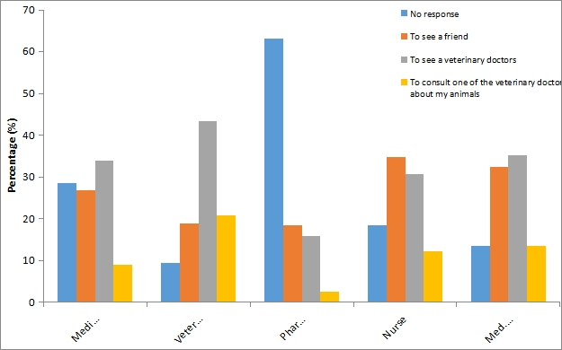

Figure I: Reasons for Visiting ABUVTH by Medical and Allied Staff of ABU

TABLE I: VISITATION TO ABUVTH BY MEDICAL AND ALLIED STAFF OF ABU
 |  | Yes |  | No |  | Total
Medical Doctor | Count |  | 10.0 |  | 46.0 |  | 56.0
Medical Doctor | (%) |  | 17.9 |  | 82.1 |  | 100.0
Veterinary Doctor | Count |  | 43.0 |  | 10.0 |  | 53.0
Veterinary Doctor | (%) |  | 81.1 |  | 18.9 |  | 100.0
Pharmacist | Count |  | 16.0 |  | 22.0 |  | 38.0
Pharmacist | (%) |  | 42.1 |  | 57.9 |  | 100.0
Nurse | Count |  | 20.0 |  | 29.0 |  | 49.0
Nurse | (%) |  | 40.8 |  | 59.2 |  | 100.0
Med. Lab/Technologist | Count |  | 21.0 |  | 16.0 |  | 37.0
Med. Lab/Technologist | (%) |  | 56.8 |  | 43.2 |  | 100.0
Total | Count | 110.0 |  | 123.0 |  | 233.0
Total | (%) | 47.2 |  | 52.8 |  | 100.0

A histogram of medical professional that visited ABUVTH Diagnostic Centre showed that, most of the Medical doctors (76.8%), Pharmacist (76.3%), Nurses (65.3%), Laboratory Scientist/Technologists (43.2%) and veterinarians (35.8%) have not been to the ABUVTH diagnostic center (Figure I ). A total of 60% of all the respondents have not been to the diagnostic center, while 27.5% have visited the center, some respondents did not respond to that aspect of the question (Figure II).

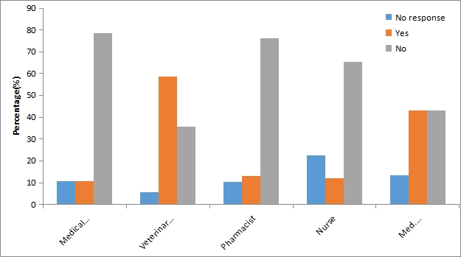
Figure II: Visitation to the ABUVTH Diagnostic Imaging Unit by Medical and Allied Staff of ABU

Among those who visited the Diagnostic Imaging Centre, the X-ray machine was the most commonly observed imaging equipment, reported by 21.9% of respondents. This was followed by fluoroscopy equipment at 3.9%, while only 1.7% reported seeing the ultrasound machine. A total of 72.5% did not respond to the question. All Veterinarians and Lab. Scientist/Technologist that visited ABUVTH diagnostic center did not see the fluoroscopy machine.

However some Medical doctors, Pharmacist and Nurses claim to have seen it at ABUVTH diagnostic center (Figure III).

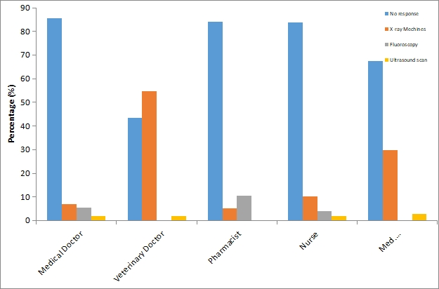
Figure III: Knowledge of various Diagnostic Imaging Facilities at ABUVTH Diagnostic Centre by Medical and Allied Staff of ABU

Most of the respondents that knew about the unit claim that they knew about the unit less than one year ago (10.3%), some knew about the unit 2 – 3 years ago (6.0%) others 4 – 5 years ago(3.4%) and the rest 6 years above4.3%). Some respondents did not respond to that aspect of the question (62.2%). A total of 94.7 % of Pharmacist did not respond to that question; followed by Medical Doctors (80.4 %) and Nurses (69.4%). A total of 13.5 % of Lab. Scientist/Technologist knew the unit one year ago, followed by the medical doctors (12.5 %) and the nurses (12.2 %). Veterinarians knew about the unit longer than any other health professionals, followed by Medical Lab/ Technologist (Table II).
TABLE II: KNOWLEDGE ON THE EXISTENCE OF DIAGNOSTIC IMAGING UNIT AT ABUVTH BY MEDICAL AND ALLIED STAFF OF ABU
 |  | NO RESPONSE | 0-1 YEAR | 2-3 YEARS | 4-5 YEARS | 6-7 YEARS |  | 8 AND ABOVE | TOTAL
Medical Doctor | Count | 45 | 7 | 2 | 1 | 0 |  | 0 | 56
Medical Doctor | (%) | 80.4 | 12.5 | 3.6 | 1.8 | 0.0 |  | 0.0 | 100.0
Veterinary Doctor | Count | 12 | 5 | 4 | 5 | 3 | 5 |  | 53
Veterinary Doctor | (%) | 22.6 | 9.4 | 7.5 | 9.4 | 5.7 | 9.4 |  | 100.0
Pharmacist | Count | 36 | 1 | 0 | 0 | 0 | 0 |  | 38
Pharmacist | (%) | 94.7 | 2.6 | 0.0 | 0.0 | 0.0 | 0.0 |  | 100.0
Nurse | Count | 34 | 6 | 3 | 0 | 0 | 0 |  | 49
Nurse | (%) | 69.4 | 12.2 | 6.1 | 0.0 | 0.0 | 0.0 |  | 100.0
Med. Lab/Technologist | Count | 18 | 5 | 5 | 2 | 1 | 1 |  | 37
Med. Lab/Technologist | (%) | 48.6 | 13.5 | 13.5 | 5.4 | 2.7 | 2.7 |  | 100.0
Total | Count | 145 | 24 | 14 | 8 | 4 | 6 |  | 233
Total | Wit (%) | 62.2 | 10.3 | 6.0 | 3.4 | 1.7 | 2.6 |  | 100.0

DISCUSSION
The findings of this study showed that veterinarians constituted the highest proportion of medical and allied professionals who had visited the Ahmadu Bello University Veterinary Teaching Hospital (ABUVTH). This finding is not unexpected, considering the professional and institutional relationship between veterinarians and the Veterinary Teaching Hospital. Considerable proportions of veterinarians in the study population were either staff members or students of the Faculty of Veterinary Medicine and, therefore, had greater institutional access and professional reasons to visit the hospital. In addition, the hospital serves as an important clinical and teaching facility for veterinary professionals within the Ahmadu Bello University environment. Consequently, their relatively higher level of visitation may reflect proximity and occupational necessity rather than greater general interest in the hospital.
Nevertheless, the observation that some veterinarians had never visited ABUVTH is noteworthy. This may be explained by differences in professional affiliation and geographical location. Some veterinarians may have been graduates of institutions other than Ahmadu Bello University and may have been working in establishments such as Mando, Samaru College of Agriculture or the National Animal Production Research Institute (NAPRI), Shika. For such professionals, the absence of a direct institutional relationship with ABUVTH may reduce the frequency of contact with the hospital. This suggests that professional proximity and institutional affiliation may be important determinants of utilization of veterinary teaching-hospital services.

It also indicates that the potential clientele of ABUVTH extends beyond ABU staff and students and should include veterinarians and other animal-health professionals working within the wider Zaria and Kaduna environment.
In contrast, medical doctors and nurses recorded the lowest levels of visitation to ABUVTH. This may be partly explained by professional role differentiation and physical distance from the hospital. Unlike veterinarians and laboratory professionals, medical doctors and nurses may have fewer routine professional reasons to visit a veterinary teaching hospital. Their lower visitation may therefore reflect limited interaction between human and veterinary healthcare services rather than a lack of awareness of the hospital. This finding is important in the context of the increasing recognition of the One Health approach, which emphasizes collaboration between human, animal and environmental health professionals. Greater interaction between medical and veterinary professionals could potentially improve awareness of the complementary diagnostic capabilities available within veterinary institutions.
Over fifty percent of the Medical doctors, Pharmacist and Nurses have not visited the ABUVTH, Diagnostic center; this may be due to the fact that they have nothing to do there. Even some Veterinarians and Lab. Scientist/Technologist have responded by saying that they have not visited the diagnostic centre, probably, because they are not ABU graduates or they have nothing to do there. Theoretical knowledge of the diagnostic imaging modalities among the respondents indicated a decline in the degree of theoretical knowledge with advancement in the technique as reported by Ibe et al. (2019).
Majority of the medical and allied health professional that visited the center saw X-ray and ultrasound machines, this is so because the unit houses an x-ray and ultrasound machines. Others claim to have seen the machine used for fluoroscopy.
The center does not have Fluoroscopy, CT and MRI equipment and any respondent who claim to have seen them saw them either at the Human Teaching Hospital or somewhere else. The findings reported by Cooley et al. (2019) are relevant to the present study because they demonstrate the importance of the availability and accessibility of diagnostic imaging facilities in promoting exposure to different imaging modalities among veterinary and allied health professionals. Cooley et al. (2019) reported that the Lois Bates Acheson Veterinary Teaching Hospital of the Carlson College of Veterinary Medicine at Oregon State University had a wide range of diagnostic imaging services, including nuclear medicine, magnetic resonance imaging (MRI), computed tomography (CT), ultrasonography, digital fluoroscopy and digital radiography, which were available for both research and diagnostic purposes in large and small animals. This contrasts with the pattern observed in the present study, where respondents' exposure was predominantly to conventional X-ray and ultrasound, with relatively limited awareness or observation of other modalities such as fluoroscopy.

CONCLUSION
This study assessed the awareness, knowledge and exposure of medical and allied health professionals to veterinary diagnostic imaging services at the Ahmadu Bello University Veterinary Teaching Hospital (ABUVTH), with particular emphasis on the Diagnostic Imaging Centre. The findings indicate that exposure to ABUVTH and its Diagnostic Imaging Centre among the medical and allied health professionals surveyed was generally limited. A considerable proportion of the respondents had never visited either the Veterinary Teaching Hospital or its Diagnostic Imaging Centre, suggesting that the services and capabilities of the facility may not be sufficiently known or utilized by professionals outside the veterinary profession.
The study also established that some medical and allied health professionals were aware that diagnostic imaging modalities used in human medicine can also be applied in veterinary medicine. The sources of this information, particularly textbooks and friends, indicate that awareness is not derived solely from direct interaction with veterinary diagnostic imaging services. Nevertheless, the reliance on informal sources of information may limit the depth and accuracy of knowledge regarding the appropriate application of these modalities in animals.

REFERENCES
Bushberg, J. T., Seibert, J. A., Leidholdt, E. M., Jr., & Boone, J. M. (2012). Fluoroscopy. In The essential physics of medical imaging (3rd ed., pp. 282–311). Lippincott Williams & Wilkins.
Cooley, S., Newsom, L. & Stieger-Vanegas, S. (2019). Veterinary diagnostic imaging at Carloncollege of veterinary medicine, Oregon state university. https://vetmed.oregonstate.edu/veterinar y-diagnostic-imaging, retrieved 30-07 2019.
Ganten, M., Radeleff, B., Kampschulte, A., Daniels, M. D., Kauffmann, G. W. & Hansmann, J. (2003). Comparing image quality of flat-panel chest radiography with storage phosphor radiography and film-screen radiography. American Journal of Radiology, 181(1), 171-176.
Graham, L. S., Kereiakes, J. G, Harris, C. & M. B. (1989). Cohen Nuclear medicine from Becquerel to the present. Radiography, 9(6), 1189-1202.
Hendee, W. R. (1989). Cross sectional medical imaging: a history. Radiograph, 9(6), 1155-1180.
Hoines, C. (2013). Digital radiography: The difference between CR and DR veterinary X-ray systems. BCF Technology.
Thomas, A. M. K. & Pickstone, J. (2007). Imaging: revealing the world within. BMJ 334.
Ibe, C. S., James, A. A. & Nzalak, J. O. (2019). Evaluation of the knowledge and application of diagnostic imaging modalities among veterinary surgeons in Nigerian veterinary medical schools, Sokoto Journal of Veterinary Sciences, 17(4), 51-61.
Macovski, J. (2009). MRI: a charmed past and an exciting future. Journal of Magnetic Resonance Imaging, 30(5), 919-923.
Mathai, R., Bhatt, R. H., Jhala, S., Kelawala, N. H., Patil, D. B., & Parikh, P. V. (2008). Current diagnostic techniques in veterinary surgery. Veterinary World, 1(3), 90–91.
Moran, D. E., & Heffernan, E. J. (2010). The evolution of whole-body imaging. Seminars in Musculoskeletal Radiology, 14(1), 3–13. https://doi.org/10.1055/s-0030-1248701.
Ohlerth, S. & Scharf, G. (2007). Computed tomography in small animals – Basic principles and state of the art applications. The Veterinary Journal, 173, 254-271.
Otto, G. (1993). Wilhelm Conrad Röntgen and the early history of the roentgen rays. Norman Publishing. pp. 10-15.
Peters, P. (1995). Roentgen and the discovery of x–rays. Textbook of Radiology. Medcyclopedia.com, GE Healthcare.

Quintela, L. A., Barrio, M., Peña, A. I., Becerra, J. J., Cainzos, J., Herradón, P. G., & Díaz, C. (2012). Use of ultrasound in the reproductive management of dairy cattle. Reproduction in Domestic Animals, 47 (Suppl. 3), 34–44. https://doi.org/10.1111/j.1439-0531.2012.02032.x.

Roon, M., Bhatt, R. H., ShivrajJhala, N. H., Kelawala, D., Patil, D. & Parikh, P. V. (2008). Current Diagnostic Techniques in Veterinary Surgery. Veterinary World, 1 (3), 90-91.

