JoSVAS 2026 September Vol. 8 Issue 3: 301-305
©2026 College of Veterinary Medicine, Case Report
Michael Okpara University of Agriculture, Umudike, Nigeria

MANAGEMENT OF DYSTOCIA DUE TO VAGINAL HYPERPLASIA IN A ONE-YEAR-OLD PRIMIPAROUS RUSSIAN SHEPHERD BITCH
^{1*}JAMES, A. A., ¹SAMBO, I. P., ¹ANKALA, R. E., ¹KPASHAM, L. Z., ¹AGWECHE, O. S., ¹KALANG, J. J & ²ANDREW, A.
¹Department of Veterinary Medicine, Surgery and Radiology University of Jos, Nigeria; ²Department of Surgery and Radiology, Ahmadu Bello University, Zaria, Nigeria

*Correspondence: chendekemen@gmail.com; +2347039762476
ABSTRACT
Dystocia is difficult birth or inability to expel foetuses through the birth canal. The aetiology of dystocia is multifactorial but may be of maternal or foetal cause. Primary uterine inertia is the most common reason for dystocia in the bitch accounting for 75% of cases. Vaginal hyperplasia in bitch is an exaggerated response of the vaginal mucosa to estrogens during the proestral–estral phase of the oestrous cycle, which can protrude through the vulvar labia, leading to dystocia. This exaggerated tissue can obstruct the birth canal or increase soft tissue resistance that impede foetal movement through the birth canal. A one- year-old Russian shepherd bitch weighing 30 kg was presented to the Small Animal Clinic unit of the University of Jos Veterinary Teaching Hospital, with chief complaints of exceeded gestation period and growth in the vagina. History also revealed that the first and last crossing days of the bitch before presentation were 70 and 65 days, respectively. On physical examination, the vital parameters were: temperature 39.7 o C, pulse rate 101 beats/minute, and respiratory rate 24 cycles/minute. Clinical findings were congested mucous membrane, foetus in the birth canal, distended abdomen, black to greenish vulva discharges, mass in the vagina and lethargy. Samples were collected and sent to laboratories and abdomino-pelvic ultrasonography was performed. Based on the history, clinical findings and laboratory results, dystocia was diagnosed; it was managed through an emergency caesarean section.
Keywords: Bitch, Caesarean Section, Dystocia, Russian Shepherd, Vaginal Hyperplasia

INTRODUCTION
Radiographic Dystocia is the inability of the dam to expel the foetus at parturition through the birth canal without assistance. Dystocia in companion animals like the bitch and queen can be life threatening. The causes of dystocia are either maternal or foetal (Kabir et al., 2017; Clare, 2023). Some of the maternal causes include uterine inertia (primary and secondary), old age, under age, breed disposition, inadequate pelvis, uterine torsion, uterine rupture, vaginal and vulvar soft tissue abnormalities, excess perivaginal fat and ruptured maternal diaphragm (Gardiner, 2019; Clare, 2023). Some foetal causes include foetal malposition, foetal oversize, foetal death, and foetal congenital defects such as anarsaca, hydrocephalus and foetal mummification (Kabir et al., 2017; Ibe et al., 2025). Criteria for diagnosing dystocia include obvious malposition, abnormally prolonged gestation, and abnormally prolonged whelping; gestation greater than 70 days from known breeding date is considered prolonged (Clare, 2023). When the bitch is unable to enter into Stage I Labour after 24-36 hours following a drop in rectal temperature to 37.20C-37.70C, or is unable to complete parturition within the appropriate time, it is considered as prolonged whelping (Gardiner, 2019). Factors such as age, breed (e.g. brachycephalic and toy breeds of dogs), obesity, sudden environmental change before labour, history of difficult parturition can predispose a bitch to dystocia (PetMD, 2009). According to Oluwatoyin & Fayemi (2011), the prevalence of dystocia in southern Nigeria as compared to other conditions was 2.9%. Furthermore, in a finding from 18,758 female dogs in the United Kingdom, the prevalence of dystocia was 3.7% (701) in the bitches (O’Neill et al., 2017). Vaginal hyperplasia in bitch is an exaggerated response of the vaginal mucosa to estrogens during the proestral–estral phase of the oestrous cycle and that can protrude through the vulvar labia, leading to dystocia. Elevated oestrogen concentrations induced marked proliferation and oedema of the vaginal mucosal tissue, resulting in eversion of the vaginal floor through the vulvar lips. Clinically, vaginal hyperplasia is classified into three types. Type I is characterized by mild protrusion of the vaginal floor into the vaginal lumen without external visibility, Type II involves protrusion of the tissues through the vulvar lips forming a pear-shaped mass and Type III is the most severe form where the prolapsed vaginal mucosa protrudes externally through the vulva (Antonov et al., 2023). When this occur during pregnancy and parturition, enlarged tissues may constitute a physical obstruction within the birth canal. This can interfere with normal foetal passage, resulting in maternal obstructive dystocia, necessitating obstetrical intervention and in some cases, Caesarean section (Antonov et al., 2023).
Management of dystocia can be achieved through a caesarean section, a delivery of neonate by surgical incisions made through the abdominal wall (laparotomy) and the uterine wall (hysterotomy) (Hedwige, 2023). It is often performed as an emergency procedure when there is difficulty with natural parturition. Although it is a common surgical procedure, it can be associated with marked mortality of the puppies and dams (Ondin & Vertegen, 2008). Some of the indications for caesarean section are dystocia, previous caesarean section delivery, breech presentation, foetal distress, and genital obstructive lesions such as tumour and vaginal hyperplasia (Hedwige, 2023).

CASE HISTORY AND CLINICAL FINDINGS
A one-year-old Russian shepherd bitch weighing 30 kg was presented to the Small Animal Clinic unit of the University of Jos Veterinary Teaching Hospital, with chief complaints of exceeded gestation period and growth in the vagina. History also revealed that the bitch was pregnant for the first time; the first and last crossing days of the bitch before presentation were 70 and 65 days, respectively. On physical examination, the vital parameters were: temperature 39.7 oC, pulse rate 101 beats/minute, and respiratory rate 24 cycles/minute. Clinical findings were congested mucous membrane, foetus in the birth canal, distended abdomen, clear mucoid vaginal discharges, mass in the vagina (Figure I) and lethargy. Clinical pathology laboratory analysis for haemogram, helminthological examination and abdomino-pelvic ultrasonography were performed.

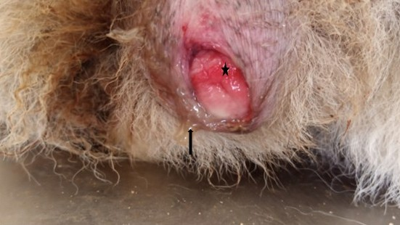
Figure I: External genitalia of the one-year old pregnant Russian shepherd bitch, showing vaginal mass (star) with discharge (arrow)

LABORATORY RESULTS
CLINICAL PATHOLOGY
Haemogram showed mild anaemia while leuogram showed severe lymphopenia and mild monocytopenia (Table I) which may indicate infection and inflammation.
Haemogram of the one-year old pregnant Russian shepherd bitch
Parameters (unit) | Patient’s values | Reference values (Hassan & Hassan, 2023)
PCV (%) | 32 | 35-57
TWBC (µL) | 16,600 | 6,000 – 18,000
Segmented Neutrophils (µL) | 13,200 | 2,900 – 12,000
Band neutrophils (µL) | 1,826 | 0 – 850
Lymphocytes (µL) | 830 | 1000 – 5000
Monocytes (µL) | 166 | 200 – 1,500
Eosinophils (µL) | 498 | 100 – 800
Basophils (µL) | 00 | 0 – 140

PARASITOLOGY LABORATORY
No haemoparasite was seen on thin blood smear stained with Giemsa and no ova/oocyst or helminth larva was seen in simple floatation and sedimentation analysis.
ULTRASONOGRAPHY
Abdomino-pelvic ultrasonography showed that the liver, kidney, spleen, and bowel loops were within normal limits, no ascites or lymphadenopathy was observed. The urinary bladder was engorged with large amount of anecogenic fluid. The uterus was enlarged and contained areas of hyperechoic, hypoechoic and anechogenicity, with a pulsating anechogenic region on real time (Figure II (A) and (B)).
Confirmatory diagnosis: dystocia due to vaginal hyperplasia, bearing live intrauterine gestation.

CASE MANAGEMENT
The patient was positioned on right lateral recumbency with restraints placed on all limbs. The left flank was shaved, washed with soap and water and disinfected with chlorhexidine. The bitch was pre-anaesthesized with 1 mg Atropine sulphate 0.02 mg/kg, and Chlorpromazine 4mg/kg intravenously; anaesthesia was achieved with 50 mg Ketamine 11 mg/kg, intravenously. The bitch was draped in a rectangular fashion.

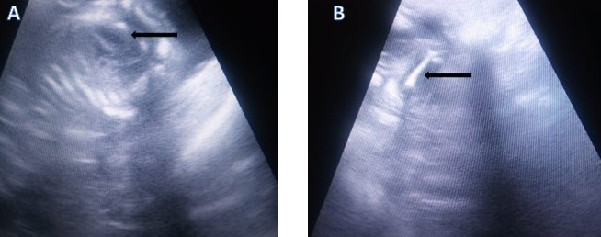 Figure II: Abdominopelvic ultrasonograph, showing A: foetal heart; B: foetal femur

The skin incision was made to include the external oblique muscles (Figure III). The internal oblique and transverse abdominal muscles were separated along their muscle fibres. This was done in order to avoid bleeding associated with transection of the fibres. The peritoneum was incised in the same direction as the skin incision.

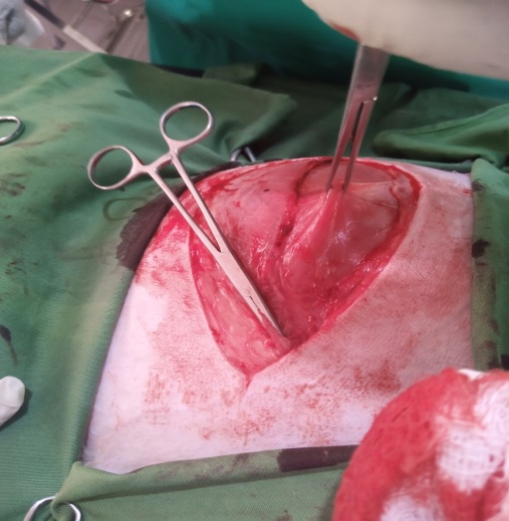
Figure III: Skin incision including the external oblique muscles
The abdominal organs were examined, paying particular attention to the uterus. The gravid uterus was exteriorized through the flank incision with minimal traction to avoid avulsing the uterine vessels or tearing the uterine wall (Figure IV). The abdominal cavity was protected from spillage of uterine contents with moistened laparotomy pads placed under and around the uterus. A stab incision was made on the ventral aspect of the uterine body, and extended with scissors. This incision was large enough to fit each puppy through without tearing of the uterine wall. The puppies were milked out of the hysterotomy, from cranial to caudal (Figure V). Each puppy in its amniotic sac and placenta, detached from the uterine wall, was delivered to the recovery team (Figure VI).
The uterus was sutured with two rows of cushion suture pattern using No. 2 chromic catgut and bites were taken only in the sub mucosa to avoid penetration of the uterine lumen. The uterus was examined for lacerations, cleaned and returned into the abdominal cavity. The peritoneum and the traverse abdominal muscles were closed with a simple continuous suture pattern using No. 2 chromic catgut. The internal abdominal muscles were closed with a simple continuous suture pattern using No. 2 chromic catgut. The external abdominal muscles were closed with a simple continuous suture pattern using No. 2 chromic catgut. The subcutaneous fascia and tissues were closed with a subcuticular suture pattern using No. 1 chromic catgut. The skin incision was closed with a horizontal mattress pattern using No. 2 silk (Figure VII). Post operatively, 10mg Oxytocin 0.5mg/kg (1ml) I/M was administered. Also, 200,000 IU/250mg Penicillin 22,000IU/kg + 20 % Streptomycin 20mg/kg (4.4ml) IM X5/7, 10mg Piroxicam 0.3mg/kg (0.6ml), IM X3/7, 100mg Iron dextran 10mg/kg (2ml) IM X3/7 and100mg vitamin B complex 10mg/kg (2ml), IM X3/7 were administered.
The vaginal hyperplasia observed in this case is a Type II since there was no complete evagination of the vaginal tissue outside of the vulvar lips. There was no need for a corrective procedure since the high circulating oestrogen levels causing this condition reduces immediately after the foetus and the placental tissues were removed. Consequently, the protruding tissues regressed back to anatomical position during the post-partum period.
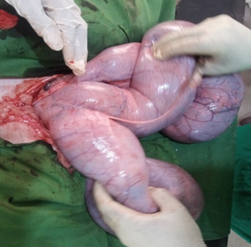
Figure IV: Exteriorization of the gravid uterus

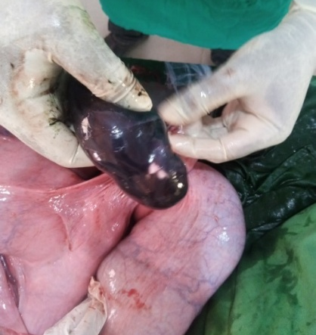
Figure V: Milking out of foetuses from exteriorized and incised gravid uterus

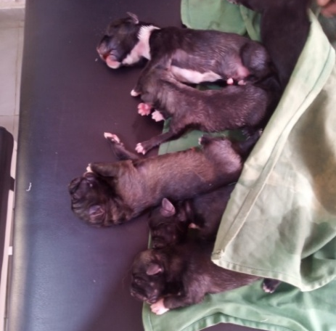
Figure VI: Delivered foetuses

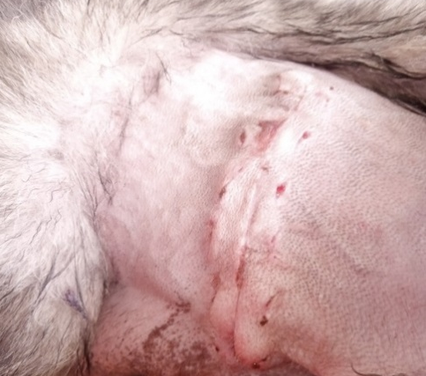
Figure VII: Healed surgical site post-surgery

DISCUSSION
Dystocia is one of the important peri-paturient emergencies observed in canine practice. Several methods have been adopted to manage dystocia with surgery as the last resort, as seen in this case. According to Long et al. (2022), canine dystocia is influenced by bitch parity, which is higher in the first parity with 80.21% occurrence; this agrees with this case because it was the bitch’s first parity.
Dystocia was diagnosed in the present case based on the clinical signs presented and was confirmed when the bitch had expressions, such as strong contractions for more than 45-60 minutes without expulsion of a puppy, weak and infrequent contractions for more than 4-6 hours without expulsion of a puppy, and obvious ultrasonographic features of foetal heart beats and fetal movements on real time B mode ultrasonography, which are strong indicators of foetal viability.
This case reports an unplanned caesarean section as a result of vaginal obstruction hindering the progression of Stage II labour. The vaginal obstruction in this case was clinically diagnosed as vaginal hyperplasia which hindered the delivery of the foetuses despite the obvious signs of labour. The case was managed through caesarean section (laparohysterotomy). This is in agreement with the previous report of Sahoo et al. (2018) that uses similar technique to manage dystocia in bitch. Besides, caesarean section is indicated for obstructive dystocia that is accompanied by systemic illness, primary or secondary uterine inertia, and prolonged active labour (Fossum et al., 2007). While caesarean section is a common surgical procedure, it may be associated with significant mortality in both dams and puppies. Timing is extremely critical for puppy survival for both emergency and elective caesarean sections. If delivery is delayed by more than 24 hours after the start of the second stage of labour, the loss of all puppies due to placental detachments usually ensues. Emergency caesarean section should be performed as soon as possible after it is determined that labour is unproductive, before the occurrence of dam exhaustion or distress of the puppies and/or the dam.
There are different available surgical approaches for caesarean section and the selection of an approach is based on the type of dystocia, the dam’s condition, the environmental conditions, the availability of assistance, and the surgeon’s preference (Weldeyohanes & Fesseha, 2020). Usually, celiotomy from the umbilicus to the pubis is most commonly performed, but a flank incision is described as an alternative (Williamson et al., 2019) which was adopted in this case. This is due to the observation that with the ventral midline incision, external skin sutures are a source of irritation for the bitch and the puppies, and puppies will frequently suckle or scratch at them, increasing the chance of incisional irritation or infection and also the abdominal organs may exert weight on the suture site leading to wound dehiscence.
The flank incision adopted in this case allows the possibility of observing the surgical wound from a distance without handling the animal, it reduces the potential for evisceration of abdominal organs from wound dehiscence and allows an active bitch to continue providing nutrition to her puppies while healing from the surgery. Thus, the flank incision proves to be a good approach to preserve and protect from all the complications arising from caudal mid-ventral approach. Real time B-mode ultrasonography is a vital diagnostic modality in diagnosing pregnancy, determining foetal abnormality and also determining the viability of the foetuses which will inform the surgeon, the best approach to manage such a dystocia.
The postoperative care involved the use of oxytocin, administered to enhance uterine involution and to stimulate milk flow, Penicillin and Streptomycin as broad spectrum antibiotic therapy to combat secondary bacterial infection, piroxicam to reduce surgical wound pain, iron dextran to stimulate erythropoiesis to replace lost blood. And vitamin B complex to boost basal metabolic rate of the bitch.

CONCLUSION
A one-year-old primiparous Russian shepherd bitch with a full-term pregnancy was presented with dystocia due to vaginal hyperplasia that obstructed the vagina. Management was by caesarean section, following ultrasonography and laboratory examinations. The foetuses survived the condition, and post-operative care was administered. It is believed that this report will be valuable to clinicians in the management of dystocia in bitches.

REFERENCES
Antonov, A., Atanasov, A., Fasulkov, I. & Karadaev, M. (2023). Clinical retrospective study of vaginal hyperplasia in the bitch (2012–2022). Reproduction in Domestic Animals, 58(10), 1352–1358. https://doi.org/10.1111/rda.14449
Clare, M.S. (2023). Dystocia in small animals. MSD Veterinary manual. www.msdvetmanual.com.
Fossum, T., Hedlund, C. & Hulse, D. (2007). Surgery of the reproductive and genital systems. Small Animal Surgery, 3, 702-740.
Gardiner, J. (2019). Dystocia in the Bitch: Veterinary Medicine. https://healthtopics.vetmed.UCdavis.edu/health-topics/c.
Hassan, A. Z. & Hassan, F. B. (2003). Introduction to Veterinary Practice. Ahmadu Bello University Press Limited, Zaria Nigeria. Pp. 47.
Hedwige, S. (2023). Caesarean Delivery. https://emedicine.medscape.com/article/263424-0 vervie.
Ibe, C. C., Oviawe, L. O., Anya, K. O., Tchokote, Y. E. & Adenaike, E.A. (2025). A case of dystocia from downward deviation of fetal head in a 3-year-old Sahelian doe. Journal of Sustainable Veterinary and Allied Sciences, 7(3), 258-262.
Kabir, A. R., Olufisayo, O. L., Adewale, A. D., Sikiru, O. A. & Lukman, O. R. (2017). Introductory Theriogenology Tutorials for Undergraduates. Pp. 70–74.
Long, S., Thu Hein, N. T., Hang, P. T., Hoai, N. T. & Bach, X. P. (2022). Canine dystocia: risk factors and treatment methods in dogs of Hanoi, Vietnam. World’s Veterinary Journal, 12(3), 90-295.
O’Neil, D. G., O’Sullivan, A. M., Manson, E. A., Church, D. B., Boag, A. K., McGreevy, P. D. & Broadbelt, D. C. (2019). Canine dystocia in 50 UK. First Opinion Emergency Care Veterinary Record, 181(4), 8894. Doi:https://www.doi.org/10.1136/vr.104944.
Oluwatoyin, A. O. & Fayami, O. E. (2011). A survey on cases of dystocia in bitch in southwestern Nigeria. Global Veterinaria, 6(1).
Ondin, J. K. & Verstegen, P. J. (2008). Caesarean section in the dog: Reproductive Medicine/Surgery, 72.
PetMD (2009). Birth Difficulties in Dogs. https://www.petmd.com/dog/conditins/reproductive/
Sahoo, A. K. (2018). Surgical management of dystocia due to secondary uterine inertia in dog; case report. Veterinary Science, 3, 260-265.
Weldeyohanes, G. & Fesseha, H. (2020). Dystocia in domestic animals and its management. International Journal of Pharmacy & Biomedical Resources, 7(3), 1-11. Reviews, 4, 237-242.
Williamson, J. A., Brisson, B. A., Anderson, S. L., Farrell, R. M. & Spangler, D. (2019). Comparison of 2 canine celiotomy closure models for training novice veterinary students. Veterinary Surgery, 1–9. https://doi.org/10.1111/vsu.13224

