JoSVAS 2026 September Vol. 8 Issue 3: 306-311
©2026 College of Veterinary Medicine, Case Report
Michael Okpara University of Agriculture, Umudike, Nigeria

PIG MORTALITY DUE TO AFRICAN SWINE FEVER INFECTION IN OTUKPO, BENUE STATE, NIGERIA
*¹ADENAIKE, E.A., ²TEKDEK, L.B., ³KAZEEM, H.M. & ⁴UMOH, J.U.
*¹Department of Veterinary Medicine, Michael Okpara University of Agriculture, Umudike, Umuahia, Nigeria. ²Department of Veterinary Medicine, Ahmadu Bello University, Zaria, Nigeria, ³Department of Veterinary Microbiology Ahmadu Bello University, Zaria, Kaduna State, ⁴Department of Veterinary Public Health and Preventive Medicine, Ahmadu Bello University, Zaria, Nigeria

*Correspondence: adenaikelara@yahoo; +2348026580689
ABSTRACT
A sow in Otukpo, Otukpo Local Government Area (LGA) of Benue state of Nigeria that earlier looked apparently healthy died 10 hours later. At Post mortem the collected organ samples are (lymph nodes, liver, lungs, spleen and kidney). All the samples were collected in containers, labelled and were placed in a cooler and covered with ice pack. These organ samples were transported to National Veterinary Research institute Vom, Plateau State Nigeria for confirmation. Polymerase chain reaction (PCR) was carried out on suspected organs. The post-mortem results showed Mandibular muscle congestion, congested lungs, intestine and Kidneys showing ecchymotic and petechial haemorrhages in the serosal surfaces, Brain congestion and oedema andgravid uterus. The PCR result of lymph node and Kidney were positive at 250 base pair. It was later confirmed that the sow died of African swine fever infection. The case was reported to the state veterinary section of the Ministry of Agriculture since African swine fever is a notifiable, highly contagious, lethal hemorrhagic disease in domestic pigs. It was recommended that other pigs from the same farm to be destroyed and the farm should be disinfected and allow to rest for four at least months.
Keywords: African swine fever, Benue state, Pig mortality, Otukpo

INTRODUCTION
African swine fever (ASF) is a notifiable, highly contagious, lethal hemorrhagic disease in domestic pigs (Rahimi et al., 2010). It is characterized by an acute generalized infection and by fever, high temperature, dullness, loss of appetite, cyanosis and incoordination of the hind legs .The incubation period is three to four days and the duration of the disease three to four days. Mortality is usually 100% ,with only an occasional survivors The lesion are most pronounced in the vascular system and is characterized by extensive hemorrhages in different organs and cavities (Merchant & Parker 2005).

The ASF is one of the 3 most dreaded epidemic diseases of pigs. The other two are swine vesicular diseases (SVD), and foot and mouth disease (FMD), (EU, 2010).The catastrophic effect of this disease on pig production, both at household and commercial levels in Africa poses serious socio-economic problems and threatens food security (Lubisi, 2005).
The clinical signs of ASF are similar to several diseases such as erysipelas and acute salmonellosis, but the major diagnostic problem is distinguishing it from hog cholera. Any febrile disease associated with hemorrhage and death should raise suspicion of ASF. Laboratory confirmation is essential and samples of blood, spleen and visceral lymph node should be collected for virus isolation and for detection of antigen. Virus isolation is done in swine bone marrow or peripheral blood leucocytes cultures, in which heam-adsorption can be demonstrated and cytopathic effect seen within a few days after inoculation. From this point, the virus can be adapted to grow in various cells (Murphy et, al, 1999).
Incubation period is 5-15 days, followed by one or (usually) more of these disease forms: per acute Infection with highly virulent virus strains can result in some pigs being suddenly found dead, or close to death (EU, 2010); acute infection: there is fever (pyrexia), loss of appetite (anorexia) and inactivity. Areas of red or blue skin discoloration may appear on the ventral chest of the abdomen, tips of rear or tail os distal limbs (EU, 2010). Diarrhoea, vomiting, coughing breathing difficulty and abortion may also occur (EU, 2010). Almost 100%, of pigs with these symptoms will die within 7days. Pigs that recover can be lifelong carriers of virus (EU, 2010); Subacute infection which is seen particularly with virus strains of moderate virulence (EU, 2010). Affected pigs are only mildly ill, but sows may abort (EU, 2010). There can be intermittent fever for up to one month, followed in most cases by recovery. Mortality ranges from 30-70% Recovered pigs can still be excreting the virus six weeks after infection (EU, 2010). In chronic infection, although there could be occasional episode of fever, these show little illness apart from reduced growth, stunting and emaciation (EU, 2010). There may be necrotic patches of skin or chronic skin ulcers (EU, 2010). They are vulnerable to secondary infections, pneumonia and lameness (arthritis). Infection last for two or five months but mortality is less than 30% (EU, 2010).
The usual route of an ASF infection in pig is via the mouth (ingestion) or the upper respiratory system (Merchant and Packer 2005). African swine fever virus (ASFV) is also transmitted from tick to tick sexually, transovarially and transstadially (Ayoade & Adeyemi, 2003). The ASF virus provokes proliferation of lymphocytes and reticular cells. After four days, degeneration becomes more prominent than proliferation (Ayoade & Adeyemi, 2003). In Infected macrophages, the virus effectively inhibits secretions and synthesis of antiviral immunomodulatory or cytokines. (Murphy et, al 1999)
Diagnostic PCR using ASF virus specific primer was carried out. PCR assay was performed as previously described by Odemuyiwa et al. (2000). The PCR primers from a conserved region of the ASF virus genome were used to detect and identify ASF isolates. ASF positive, negative and test tissue samples were added to separate tubes containing PCR amplification buffer and Taq DNA polymerase. The tubes were placed in a DNA thermal-cycler and subjected to a programmed cycle of heating and cooling. Samples were taken from each tube and loaded into lanes in gel containing ethidium bromide; control lanes contain DNA markers and were electrophoresed. The gel was examined over UV light, if ASF virus was present in the sample a discrete band will be present that will co-migrate with the PCR product of the positive control.
The size of the PCR products were compared with the DNA markers, the positive control was 278 base pairs. No bands were seen in the negative control.
The gross pathological changes are similar to those of hog cholera characterized by lesions of the circulatory system. Generally, the lesions are proportional to the amount of damage to the circulatory system. Also, these lesions are usually marked in acute cases that are due to highly virulent viruses, whereas they may be minimal or absent when due to low virulent viruses causing inapparent or chronic forms of the disease. The circulatory system is probably the most severely damaged tissue of the body as evidenced by congestion, edema, ascites, hydrothorax, hydropericardium, infarctions and occasional necrosis in many visceral organs, and changes in the blood. Petechial and ecchymotic hemorrhages are often seen on the epicardium, around engorged coronary blood vessels on the epicardium and endocardium. Also, they are found around attachments of the chordae tendinae to the valves and endocardium. Lymph nodes are hemorrhagic and edematous. Severely affected lymph nodes may look like hematomas. Spleen may be enlarged and lungs usually appear congested. Pneumonia may be seen in chronic cases. Kidneys and urinary bladder are usually seen with petechial and ecchymotic hemorrhages. Leucopenia is marked in acute ASF, with increase in the percentage of neutrophil mature forms especially and with concomitant drop in lymphocyte numbers. In chronic ASF hypergammaglobulinemia is often marked. Also, the brain and meninges are often congested, edematous and may contain multiple hemorrhages. Since the necropsy lesions resemble those of hog cholera, salmonellosis and erysipelas, laboratory confirmation of ASF is imperative (Ayoade & Adeyemi, 2003).

Petechial (Pin point) haemorrhages are very typical, especially in the cortex, medulla and pelvis of the kidneys, the mucous membranes of the larynx and bladder and on visceral surface (EU, 2010). Lymph nodes are enlarged and heamorrhages may be seen at the gastrohepatic and renal lymph nodes (EU, 2010). Blood splashes (ecchymosis) may be present on the skin of the leg and abdomen (EU, 2010). The spleen is often enlarged and there be excessive fluid in the abdominal, pleural and pericardial cavities (EU, 2010). Oedema of the gall bladder and mesentery of the colon is also quite typical of ASF (EU, 2010). In chronic cases, lungs may show focal lesions of caseous necrosis and even mineralization (EU, 2010). Laboratory diagnosis is essential for the confirmation of the disease presence, for the follow up of the epidemiological situation and for the implementation of the epidemio-surveillance programme which is based mainly on laboratory testing (El-Hicheri, 1998).

CASE HISTORY
A sow inOtukpo, Otukpo Local Government Area (LGA) of Benue state of Nigeria that that was purchased from a private pig farm and earlier looked apparently healthy died 10 hours later. The organs collected were lymph nodes, liver, lungs, spleen and kidney. All the samples were collected aseptically in containers, labelled and were placed in a cooler and covered with ice pack.
The samples were sent to the diagnostic centre of the Pan African Centre of Epizootics (PACE) area office in National Veterinary Research Institute (NVRI) Vom Plateau State Nigeria for laboratory confirmation. The case was also reported to the state Veterinary section under Ministry of agriculture since ASF is a notifiable, highly contagious, lethal hemorrhagic disease in domestic pigs.
RESULT
POSTMORTEM FINDINGS
Post mortem on the sow showed lesions of ASF. The lesions were characterized by congestion of organs such as brain, lungs, liver and spleen. There were ecchymotic and petechial haemorrhages on muscles, kidneys and intestines and also gravid uterusof a pregnant sow. There were also blood-stained fluids in the pleural and peritoneal cavities.
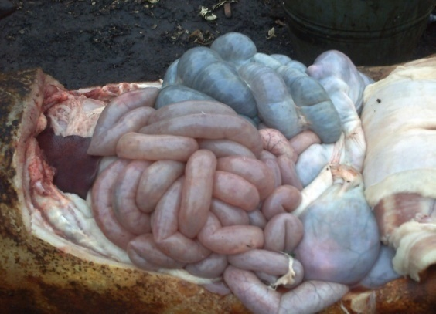Figure I: Small and Large Intestines of a pregnant so that died of African Swine Fever in Otukpo, Otukpo Local Government Area, Benue State showing ecchymotic and petechial haemorrhages in the serosal surfaces of the small and large intestines
Ecchymotic Haemorrhages

Petechial Haemorrhages

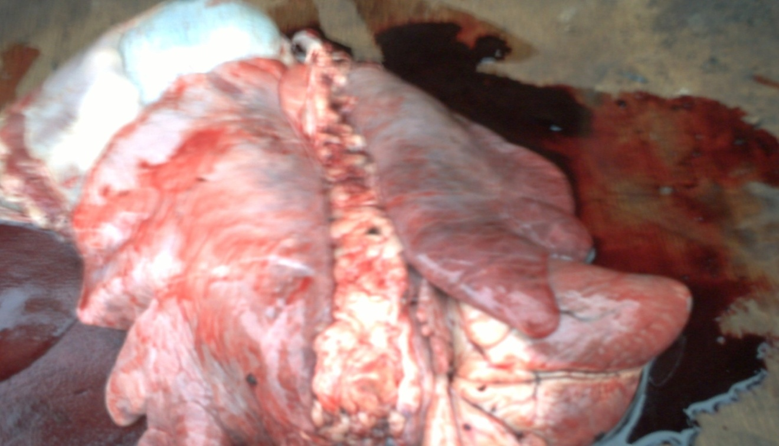Figure II: Congested lungs of a pregnant so that died of African swine fever in Otukpo. Otukpo LGA, Benue State
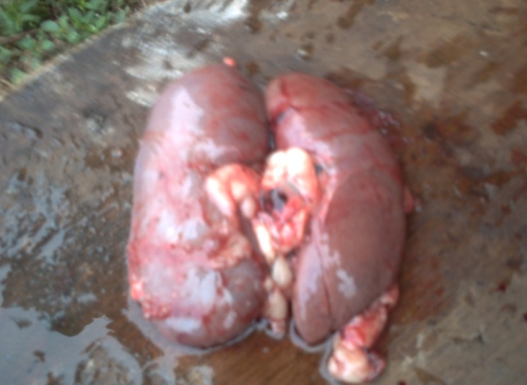Figure III: Kidneys of a pregnant so that died of African swine fever in Otukpo. Otukpo Local Government Area, Benue State showing ecchymotic and petechial haemorrhages all over the surfaces
Petechial Haemorrhages
Ecchymotic
Haemorrhages

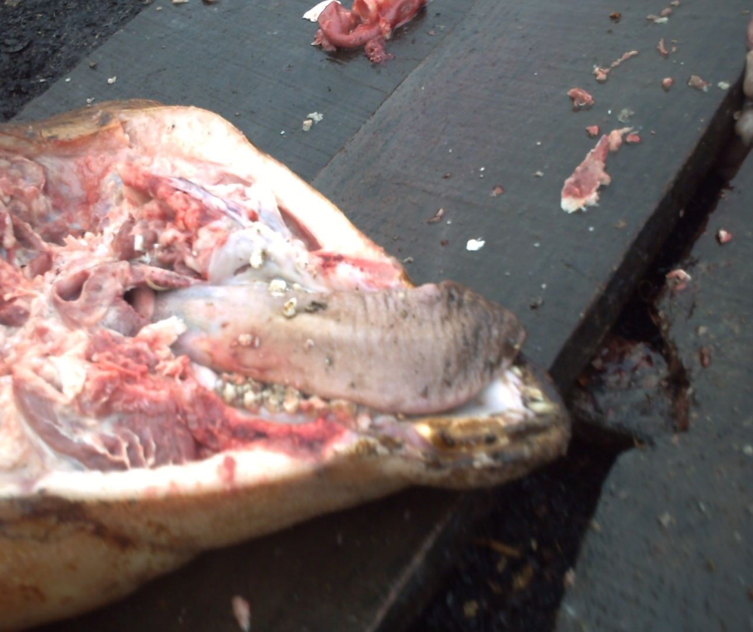
Congested
Mandibular
muscle

Figure IV: Congested Mandibular muscle of a pregnant sow that died of African swine fever in Otukpo, Otukpo Local Government Area, Benue State.
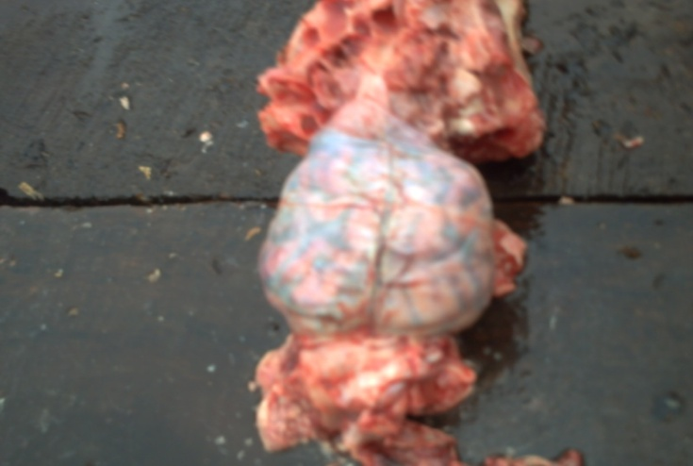Figure V: Brain of a pregnant so that died of African swine fever in Otukpo, Otukpo Local Government Area, Benue State showing congestion and oedema all over the surfaces
Oedematous areas of the brain
Congested areas of the brain

Figure VI: Gravid uterusof a pregnant sow that died of African swine fever in Otukpo, Benue State
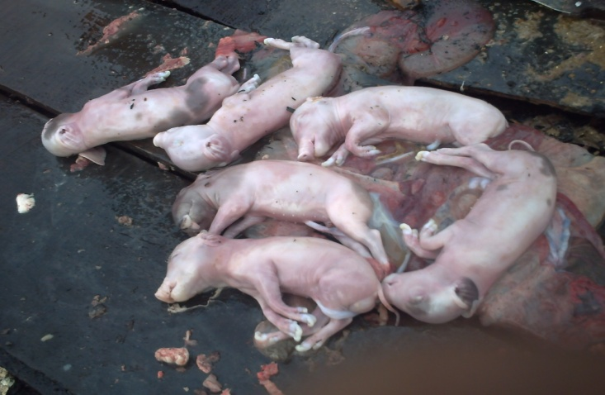
Figure VII: Dead foetuses from a pregnant sow that died of African swine fever at the 3rd trimester of Gestation in Otukpo, Otukpo Local Government Area, Benue State

The diagnostic centre of the Pan African Centre of Epizootics (PACE) area office in National Veterinary Research Institute (NVRI) Vom Plateau State Nigeria confirmed using PCR that the sow died of ASF infection as seen in Figure VIII.

.POLYMERASE CHAIN REACTION (PCR) RESULTS
M 1 2 3 4
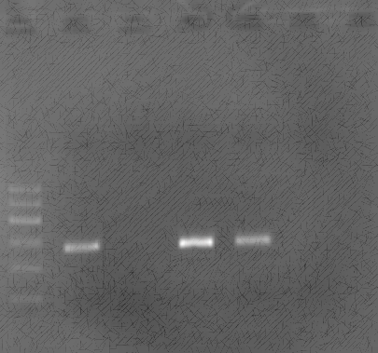

500bp

257bp
100bp

Figure VIII: Transcriptase PCR on Ager rose electrophoresis of various organ samples of sow that died of African swine fever from Otukpo Local Government Area, Benue State
All these were sero-positive indicated by bands of 257 basepair. Lane M 100 bp DNA ladder and lanes 1-12 PCR amplicons.
Positive control------------------------------------------- Lane 1
Negative control------------------------------------------ Lane 2
Lymph node----------------------------------------------- Lane 3
Kidney----------------------------------------------------- Lane 4
DISCUSSION
This confirmation has serious implication because according to Rahimi et al. (2010). The ASF is a notifiable, highly contagious, lethal hemorrhagic disease in domestic pigs. Ayoade & Adeyemi (2003) described ASF as a devastating viral disease currently threatening the pig industry worldwide. This is so because outbreak of ASF is characterized by a mortality ranging from 50 to 100% (Otesile, 2005).
The prevention and control of ASF are difficult because there is no vaccine for the infection, transmission of virus in fresh meat and pork products and the existence of persistent infection in some swine, the clinical similarity of hog cholera, and the recognition that soft ticks in some part of the world are involved in transmission of the virus (Lazarus et al., 2010). The presence of the virus in ticks and warthogs in many countries of sub-Saharan Africa makes it difficult to break sylvatic cycle of the virus. However, domestic swine can be reared in Africa if the management system avoids feeding uncooked waste food scraps and prevent access of ticks and contact of warthogs, usually by double fencing with a wire mesh perimeter fence extending beneath the ground (Murphy et al., 1999). Control depends first on early recognition and rapid laboratory diagnosis. Once ASF is confirmed in a country that has previously been free of disease, it is important to carry out prompt action to control and then eradicate it.
A recent workshop revealed slaughter without adequate compensation, rather than reduce the problem, it is aggravated, because pig farmers choose to sell their infected animals as live pigs and pig products. It has therefore been recommended that compensation be paid to pig farmers to enable them restock (EL-Hicheri, 1998). This will make farmers report the disease instead of spreading it by mass sales of infected pigs.

RECOMMENDATION
The client was advised to destroy all sick pigs and carcasses and litters buried deeply at site with lime. They were also advised to disinfect and fumigate the pens and allow them at least 4 months rest before restocking. Practices such as loaning boars, feeding of swill to pigs that contain raw or insufficiently cooked pork and pig remnants or access to such remnants through scavenging should be avoided.
The following steps should be taking to eradicate ASF in Otukpo and other parts of Benue State and Nigeria in general;
1) Biosecurity measures such as control of personnel from other pig farms, visitors, butchers and provision of foot deep .Farm equipment such as shovels and wears must not be lent out to other farms. Cooking all garbage or food left-overs to be giving to pigs. The use of blood meal made from blood of pigs for other pig feed should be discouraged.
2) Ticks must be controlled. This will help in controlling the soft ticks of the genus Ornitodorus spp. that transmit the virus. Domestic pigs should not be allowed to have contact with the wild pigs (warthogs, bush pigs, and giant forest boars) since this will help in braking the cycling of virus between soft ticks of the genus Ornitodorus and wild pigs.
3) Prohibition of movement of pigs from one part of the country to another that is free of the disease unless the animals are confirmed by veterinarians to be free from the virus.
4) Pig pens should be disinfected with strong solution of caustic soda 4 months before animals are reintroduced.
5) Quarantine, compulsory slaughter of infected and contact animals and other animals at risk with adequate compensation to the owners.
CONCLUSION
The laboratory report confirmed that the pregnant sow was suspected to have died of ASF infection which indicates the presence of the disease in Otukpo, Otukpo Local Government Area, Benue State, Nigeria. This has also added to epidemiology knowledge of ASF in Nigeria. Since the sow was suddenly found dead without previous clinical signs some few hours back it might have died from the peracute infection which is caused by highly virulent virus strains

ACKNOWLEDGEMENT
The authors are grateful to management of NVRI Vom and numerous staff that assisted in the laboratory work. The authors are grateful to the staff of Benue State ministry of Agriculture especially the veterinary section for their corporation during the event.
REFERENCES
Ayoade, G. O. & Adeyemi, I. G. (2003). African swine fever: an overview Pigtrop the information center about pig production and pork meat commodity chains indeveloping countries. Journal of Tropical Livestock Science (RevueÃ‰lev), 3-4. 129- 134.
EU (European Union. (2010). News Reports African Swine Fever outbreaks & epidemic 2010 Internal control measures for African Swine Fever; OIE. www. Pig health.com/ASF htm copyright Pig Disease information centre 2010 Pig Health.com.
EL-Hicheri, K. (1998. Emergency assistance on control and eradication of an outbreak of Africn swine fever in Western Nigeria. Report of the FAO Consultancy Mission to Nigeria. TCP/NIR/7822(E). FAO, Rome.
Lubisi, B. A., Bastos, A. D. S., Dwarka, R. M. & Vosloo, W. (2003). Genotyping African Swine Fever virus strains from East Africa. Proceedings of the 3rd annual congress of the Southern African Society for veterinary Epidemiology and Preventive Medicine, Pretoria, pp. 10 - 14.
Merchant, I. A. & Parcker, R. A. (2005). Veterinary Bacteriology and Virology CBS Publisshers and Distributors 4596/ I-A, 11 Daryaganji, New Delhi,=110002 (India) Seveth Edition Pp 703.
Murphy, F. A., Gibbs, E., Poul, J., Horzineck, M. C. & Uddert, M. K. (1999).Veterinary Virology Third Edition San Diego London. Botson. New York Sydney. Tokyo Toronto Pp293-298
Otesile, E. B., Ajuwape, A. T. P., Odemuyiwa, S. O., Akpavie, S. O., Olaifa, A. K. & Odaibo, G. N. (2005). An outbreak of African swine fever in Nigeria. Revue Élev. Méd. vét. Pays Trop, 58 (1-2), 21-26.
Radostits, O. M., Gay, C. C., Hinchcliff, K. W. & Constable, P.D (2007). Veterinary Medicine, A textbook of the diseases of cattle, horses, sheep, pigs and goats 10th, Edition Saunders Ltd. ISBN: 978-0-7020-2777-2 Pp. 1167-1173.
Rahimi, P., Sohrabi, A., Ashrafielan, J. E., Rosita, A. M., Masoudi, O., Mostofi, S. & Azadmanesh, K. (2010). Emergence of African swine fever virus, North western. Emerging Infectious Diseases, Pp1946.

